Assignment – 11.5
Name:P.Vamshi Krishna Batch: 21
Ht.no: 2303A51452

Task Description #1 – Stack Implementation
Task: Use AI to generate a Stack class with push, pop, peek, and is_empty methods. Sample Input Code: class Stack:
pass

Expected Output:
- A functional stack implementation with all required methods and docstrings.

Prompt Used to AI
“Generate a Python Stack class with push, pop, peek, and is_empty methods with comments and docstrings.”

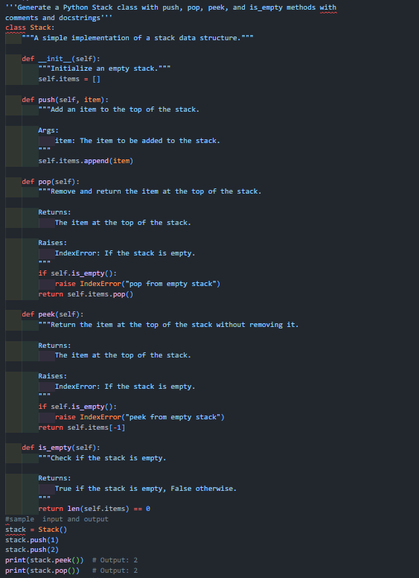

Observation
The Stack data structure works in LIFO order. AI-generated code improved clarity using docstrings and error handling.

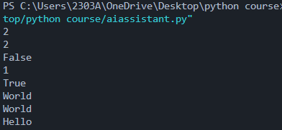

Task Description #2 – Queue Implementation Task:
Use AI to implement a Queue using Python lists. Sample Input Code:
class Queue:
pass
Expected Output:
- FIFO-based queue class with enqueue, dequeue, peek, and size Methods

Prompt
“Generate a Queue class using Python list with enqueue, dequeue, peek, and size methods.”

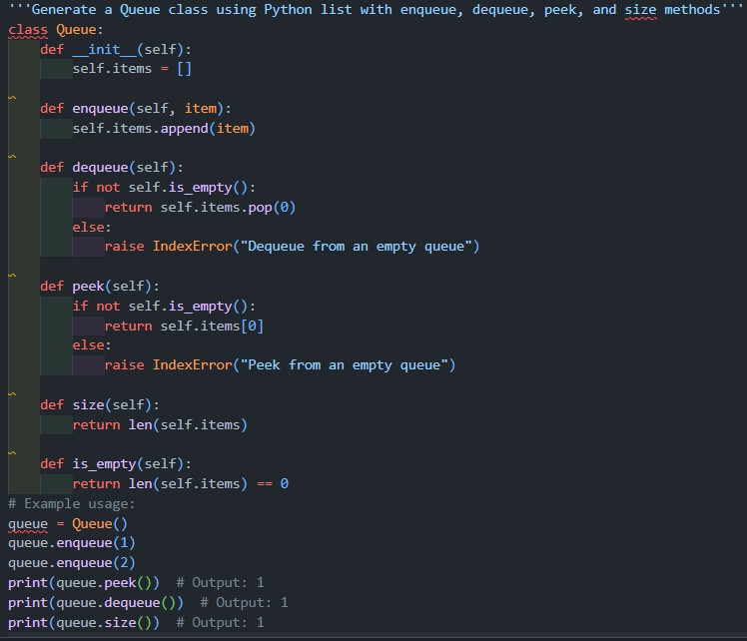

Observation
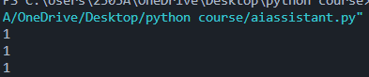
Queue follows FIFO principle. AI helped in designing efficient queue operations.

Task Description #3 – Linked List
Task: Use AI to generate a Singly Linked List with insert and display methods. Sample Input Code: class Node:
pass
class LinkedList:
pass
Expected Output:
- A working linked list implementation with clear method documentation.
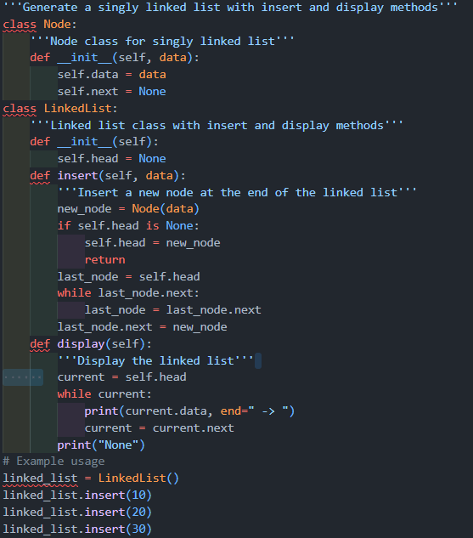
Prompt: “Generate a singly linked list with insert and display methods.”

Observation
Linked list stores nodes dynamically. AI-generated structure simplified pointer handling.

Task Description #4 – Hash Table
Task: Use AI to implement a hash table with basic insert, search, and delete methods. Sample Input Code: class HashTable:
pass
Expected Output:
- Collision handling using chaining, with well-commented methods.

Prompt
“Generate a Hash Table class with insert, search, delete using chaining.”

Observation
Hash table enables fast O(1) lookup. AI suggested chaining to handle collisions.

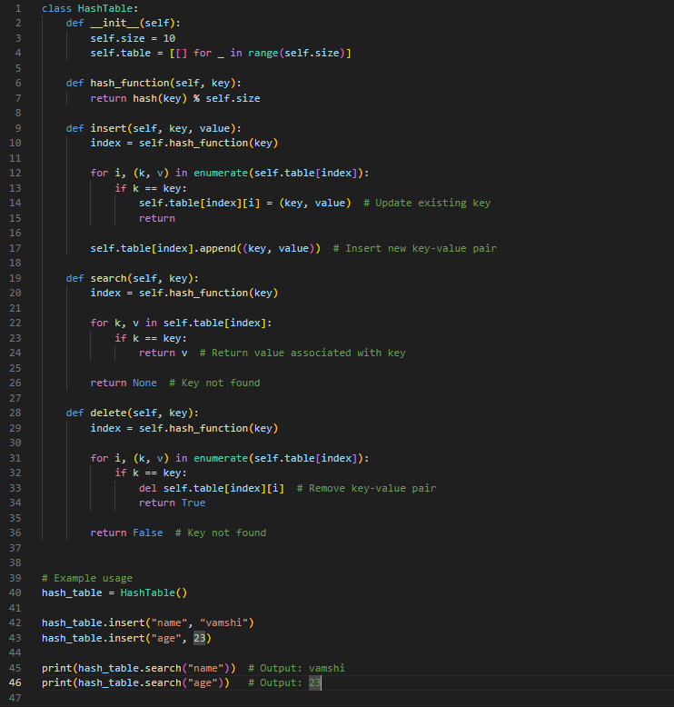
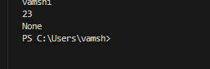

Task Description #5 – Graph Representation
Task: Use AI to implement a graph using an adjacency list. Sample Input Code:
class Graph:
pass
Expected Output:
- Graph with methods to add vertices, add edges, and display connections.

Prompt
“Generate a Graph class using adjacency list with add_vertex, add_edge, display methods.”
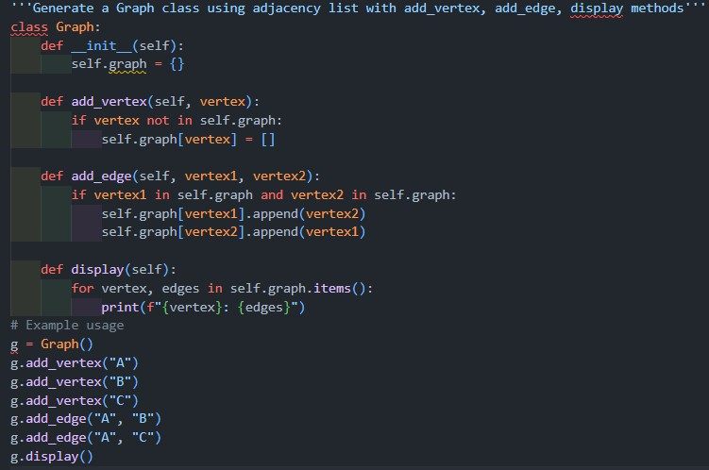

Observation
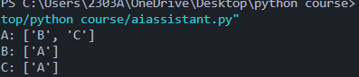
Graph adjacency list efficiently stores network connections. AI helped in structuring graph logic.

Task Description #6: Smart Hospital Management System – Data
Structure Selection
A hospital wants to develop a Smart Hospital Management System that handles:
- Patient Check-In System – Patients are registered and treated in order of arrival.
- Emergency Case Handling – Critical patients must be treated first. 3. Medical Records Storage – Fast retrieval of patient details using ID.
- Doctor Appointment Scheduling – Appointments sorted by time.
- Hospital Room Navigation – Represent connections between wards and rooms.
Student Task
  - For each feature, select the most appropriate data structure from the list below:
- Stack o Queue o Priority Queue o Linked List o Binary Search
Tree (BST)
- Graph o Hash Table o Deque
  - Justify your choice in 2–3 sentences per feature.
  - Implement one selected feature as a working Python program with AI-assisted code generation.
Expected Output:

  - A table mapping feature → chosen data structure → justification. • A functional Python program implementing the chosen feature with comments and docstrings.
Feature
Patient Check-In
Emergency Handling Medical Records
Data Structure Justification
Queue
FIFO order for patient arrival
Priority Queue Critical patients treated first
Hash Table
Appointment Scheduling BST
Room Navigation Graph
Fast ID-based retrieval
Sorted by time
Represents connected rooms

Task Description #7: Smart City Traffic Control System
A city plans a Smart Traffic Management System that includes:
- Traffic Signal Queue – Vehicles waiting at signals.
- Emergency Vehicle Priority Handling – Ambulances and fire trucks prioritized.
- Vehicle Registration Lookup – Instant access to vehicle details. 4. Road Network Mapping – Roads and intersections connected logically.
- Parking Slot Availability – Track available and occupied slots. Student Task
  - For each feature, select the most appropriate data structure from the list below:
- Stack o Queue o Priority Queue o Linked List o Binary Search
Tree (BST)
- Graph o Hash Table o Deque
  - Justify your choice in 2–3 sentences per feature.

  - Implement one selected feature as a working Python program with AI-assisted code generation.
Expected Output:
  - A table mapping feature → chosen data structure → justification. • A functional Python program implementing the chosen feature with comments and docstrings.

Feature | Data Structure | Justification
Traffic Signal Queue | Queue | Vehicles wait in order
Emergency Priority | Priority Queue | Ambulances first
Vehicle Lookup | Hash Table | Instant access
Road Network | Graph | Intersections and roads
Parking Slots | Deque | Add/remove from both ends

Task Description #8: Smart E-Commerce Platform – Data Structure Challenge
An e-commerce company wants to build a Smart Online Shopping System with:
- Shopping Cart Management – Add and remove products dynamically.
- Order Processing System – Orders processed in the order they are placed.
- Top-Selling Products Tracker – Products ranked by sales count.
- Product Search Engine – Fast lookup of products using product ID.
- Delivery Route Planning – Connect warehouses and delivery locations. Student Task
  - For each feature, select the most appropriate data structure from the list below:
- Stack o Queue o Priority Queue o Linked List

- Binary Search Tree (BST)
- Graph o Hash Table o Deque
  - Justify your choice in 2–3 sentences per feature.
  - Implement one selected feature as a working Python program with AI-assisted code generation.
Expected Output:
  - A table mapping feature → chosen data structure → justification. • A functional Python program implementing the chosen feature with comments and docstrings.

Feature | Data Structure | Justification
Shopping Cart | Linked List | Dynamic add/remove
Order Processing | Queue | FIFO order
Top Products | Priority Queue | Ranked by sales
Product Search | Hash Table | Fast lookup
Delivery Routes | Graph | Location connections

